**Coding Contribution Release 2**

Team 14 – Community Organization (Yee Chen Fong n9602976)

My contribution in terms of coding in Release 2 is more towards fixing bugs and appending my teammates existing code.

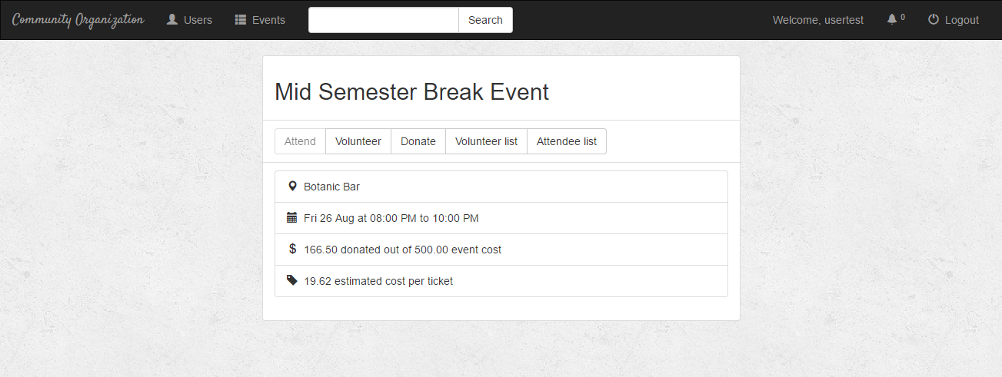

**Figure 1. Event Page (eventPage.html)**

My job is to mainly fix the syntax and logic errors for the Django views in the **events/views.py**.

Moreover, I have contributed a bit in coding the display layout of the event information details page.

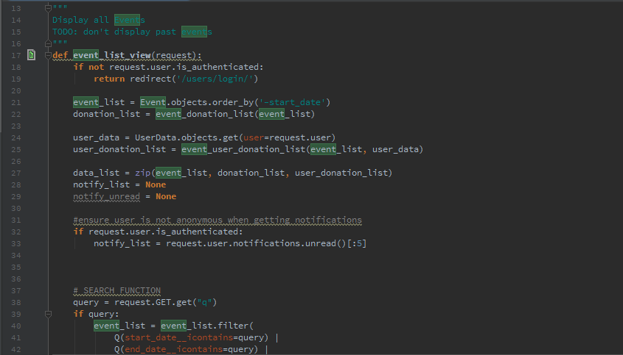

**Figure 2.1. Code involvement in the views for Event information details page (events/views.py)**

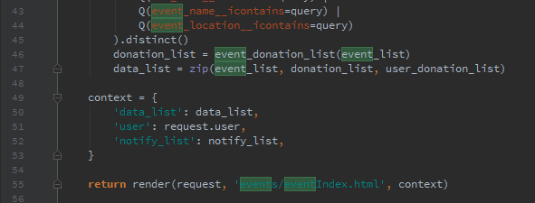

**Figure 2.2. Code involvement in the views for Event information details page (events/views.py)**

Lastly, I have also contributed in creating a splash page for the Community Organisation website.

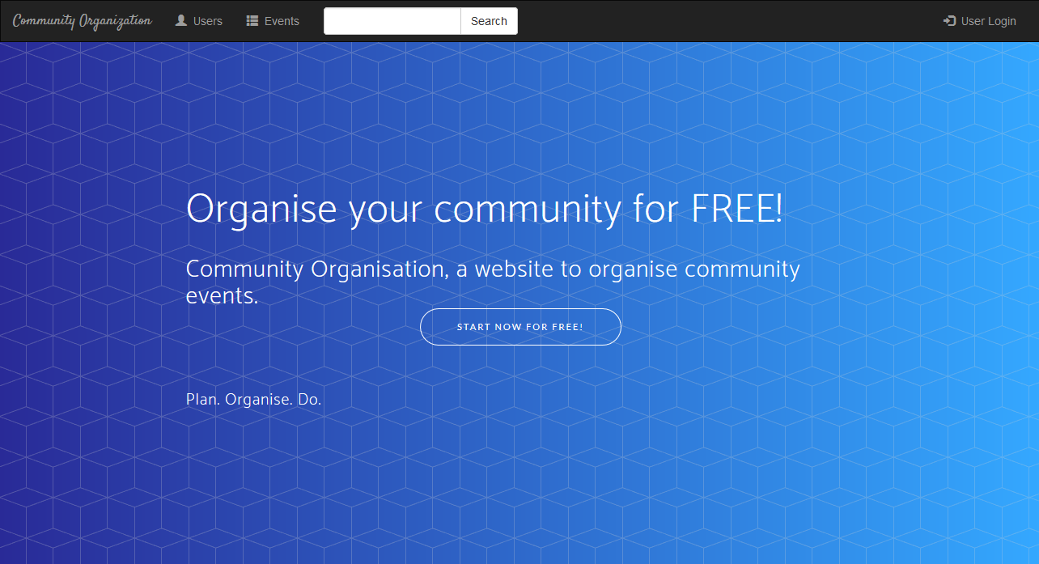**Figure 3. Splash Page – initial stage (splash.html)**

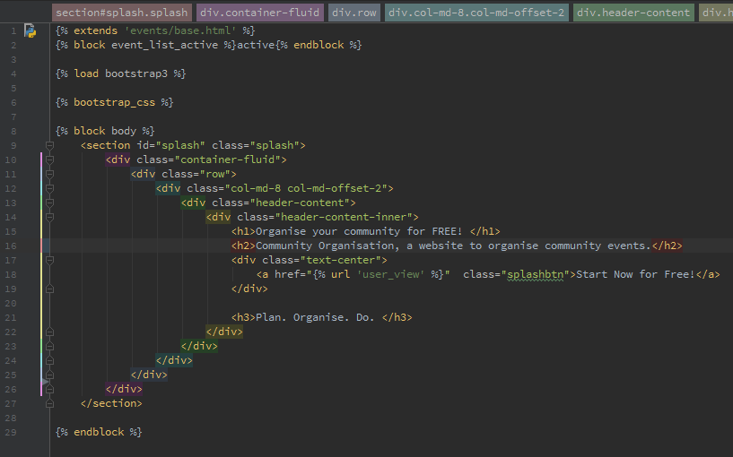

**Figure 4.1. Involvement in coding splash.html**

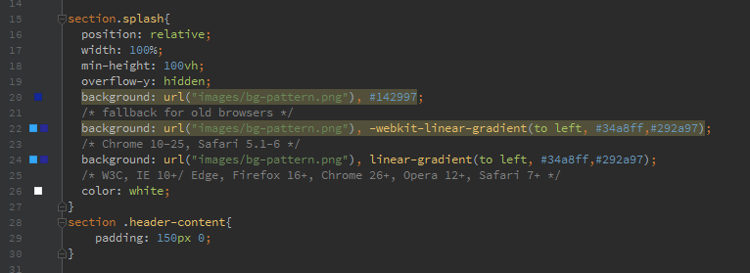

**Figure 4.2. Involvement in coding the CSS for splash.html**